**Cloud Computing: Implementation and History**

**______________________________________________**

Matthew Bluestein

University of Florida, 2016

**Table of Contents**

Introduction…………………………………………………………………………...……………2

History of Virtualization……………………………………………………………..……………..2

1. Parallel Processing…………………………………………………………………….2
2. Multiprogramming……………………………………………………………………2
3. Multiprocessing……………………………………………………………………….3
4. Symmetric Multiprocessing Systems (SMP) …………………………………………3
5. Massive Parallel Processing…………………………………………………………..3
6. Cloud Computing……………………………………………………………………..3

Current State of Cloud Computing ……………………………………………………….………..3

1. Necessary Characteristics……………………...……………………………………...4
2. Service Models………………………………………………………………………..4
3. Deployment Models…………………………………………………………………..5

Application of Cloud Computing…………………………………………………………………..5

1. Design Patterns…………….………………………………………………………….5
2. Example: Apple……………………………………………………………………….6

References………………………………………………………………………………………….7

**Table of Figures**

Figure 1: The Development of Virtualization...……………………….………………………….2

Figure 2: Workflow of the Cloud………………...……………………………………………….3

Figure 3: Summary of Cloud Computing...……………………………………………………….6

Figure 4: Practical Cloud Use……………………………………………………………………...6

**Introduction**

This paper will discuss the virtualization of large scale systems and how this virtualization has led to cloud computing. Cloud computing is a rapidly evolving concept, however the National Institute of Standards and Technology defines it as “Cloud computing is a model for enabling ubiquitous, convenient, on-demand network access to a shared pool of configurable computing resources (e.g., networks, servers, storage, applications, and services) that can be rapidly provisioned and released with minimal management effort or service provider interaction [4].” The cloud model has five main characteristics, three service models and four deployment models [5] that will be discussed in the second section. Lastly the corporation Apple will be discussed in how they utilize cloud computing to get their services to their customers.

**History of Cloud Computing**

Computer started out with one single processor[1] that could do one task at a time. Over time people have figured out ways to make computers process information faster. Virtualization is the creation of virtual operating systems, servers, storage devices or network resources [4]. There have been many advances in the virtualization[2] of information, and the following processes were the major steps within virtualization that led to cloud computing. Cloud computing is a type of virtualization that is especially useful for meeting the demands of clients. The dates alongside the concepts are the dates the concept was first used; however, the concepts have continued to evolve symbiotically to this day.

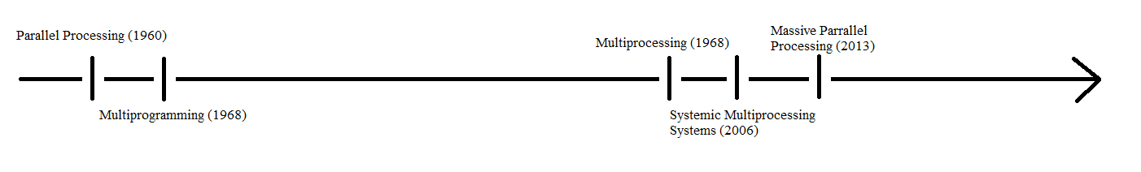

Figure The Development of Virtualization: All of the steps above are used together in order to create systems large enough to support a cloud that supplies services to millions of people.

1. **Parallel Processing[3] (1960) [6]**

Parallel processing was the advancement that allowed multiple programs to be executed at the same time [6]. This allows the computer to complete the objective in less time than by running one program after the other is completed [6].

1. **Multiprogramming[4] (1968) [6]**

The ability for multiple users to be able to use the processor for a short amount of time, taking turns [6].

1. **Multiprocessing (2004) [6]**

This advancement allowed multiple processors to share a common workload [6]. One processor would take the workload and then shift the work onto the other processor if it was overloaded [6]. The main problem with this is it did not increase efficiency that much because the processors did not work in synch.

1. **Symmetric Multiprocessing Systems (SMP) (2006) [6]**

This fixed the previous problem of one processor taking all of the workload [6]. This aimed to achieve sequential consistency, or to make all the processors working on the task seem like one efficient processor [6].

1. **Massive Parallel Processing (2013) [6]**

“Massive” entails at least hundreds of microprocessors that work in parallel to work as one massive computer [6]. This had allowed for one massive system to be created that supplies a large amount of customers. Cloud computing was created before, however without massive parallel processing the clouds created could not support the millions of consumers they do today [6].

1. **Cloud Computing (2002-2009) [6]**

All of the above advancements in processing have helped with the creation of one of the newest phenomena in computer science; cloud computing. These advancements created systems that have enough processing power in order to create a cloud platform[5] able to support millions of customers [2] and able to have many users access information from this platform simultaneously [6].

**Current State of Cloud Computing**

Computing is the method of running application software and storing related data in a central computer system through an internet connection [5]. The following diagram demonstrates how cloud computing works on its most basic level. The information following this diagram is what sets cloud computing apart from regular computing.

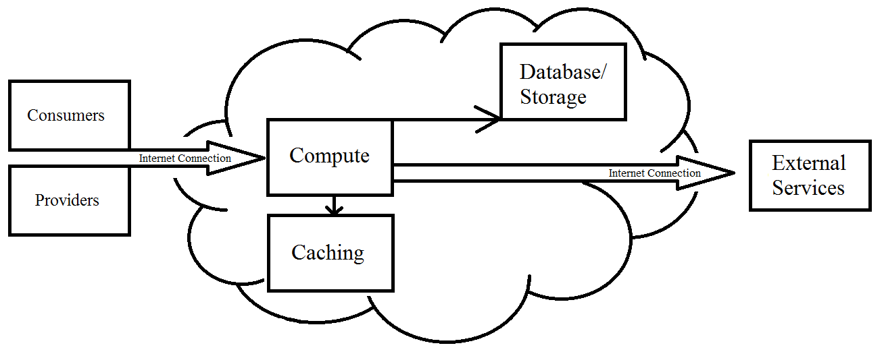

Figure Workflow of the Cloud: Consumers and providers use an internet connection with their secured usernames and passwords in order to access the services provided by the cloud. All actions are cached and necessary information is stored in the database. With this internet connection information is delivered to a person outside the cloud (this could be a consumer or provider) in order to accomplish the task at hand.

1. **Necessary Characteristics:**

A cloud infrastructure is a system of hardware and software that supplies storage, processing, memory and network bandwidth[6]. This must have the following characteristics in order to be considered ‘true’ cloud computing.

1.1 *On-Demand Self-Service*: the customer can utilize computing power[7], to accomplish tasks such as network storage and utilizing server time, as needed by the consumer. The cloud automatically provides such services without the need for assistance from the provider [5].

1.2 *Broad Network Access*: the amount of resources used is decided by how much the consumer wishes to consume, not by how much the provider supplies [5]. The network must also be accessible through standard mechanisms[8], making it available on a multitude of devices [4].

1.3 *Resource Pooling*: the provider’s computing resources are brought together in order to serve multiple customers [5]. The location of the provider is unknown to the customer and independent of the services provided [4].

1.4 *Rapid Elasticity*: the provider has the ability to distribute resources quickly and dynamically[9] [4]. This means that as demand grows and shrinks, the cloud system in place can adapt to handle large loads and release certain resources when there is less strain on the system [4].

1.5 *Measured Service*: the amount of resources used is tracked at the distribution level and the cost for these resources is dependent on the amount of resources used [4].

1. **Service Models**

What the cloud does for the consumer varies depending on the company that provides it and the needs of the customer.

2.1 *Software as a Service (SaaS)*: the client can use the provider’s applications while running on their cloud infrastructure[10] [3]. The applications are accessible through a thin client interface[11], such as the web or a program interface[12] [3].

2.2 *Platform as a Service (PaaS)*: the customer has the capability to deploy their own acquired or created applications onto the cloud infrastructure provided [3]. The consumer does not control the infrastructure of the network, but rather the applications on the network and the settings for the environment those applications reside in [3].

2.3 *Infrastructure as a Service (IaaS)*: the consumer has the ability to run arbitrary software including operating systems and applications [3]. The consumer only has control over operating systems[13], storage and deployed applications[14], not the underlying cloud infrastructure [3].

1. **Deployment Models**

The way that the cloud can be accessed depends on the purpose for the network. Certain people have access to the service provided by the cloud depending on the way the network is set up.

3.1 *Private Cloud*: owned by one organization and can be distributed to multiple consumers for use [3].

3.2 *Community Cloud*: the service is provisioned for an exclusive community of consumers [3]. It may be owned, managed and operated by multiple organizations within the community or by a third party provider [3].

3.3 *Public Cloud*: made for use by the general public. These clouds may be provided by business, academic, or government organizations, or some combination of them [3]. The hardware used exists on the premise of the cloud provider [3].

3.4 *Hybrid Cloud*: made up of two or more of the distinct cloud infrastructures stated above, brought together by standardized and proprietary technology[15] [3].

**Example of Cloud Computing**

1. **Design Patterns**

1.1 Load Balancer: when many workers do the same job and one person needs to send a request to all of them, a load balancer is used in order to allocate requests and respond to the person that send the request [7].

1.2 Scatter and Gather: when a request has to be broken down, distributed to specific workers and then the responses are returned to the person that requested it [7].

1.3 Caching: a cache stores all previous queries after using load balancer or scatter and gather [7]. These are used for future requests and if no request is found in the cache when making a request, then another one is made [7].

1.4 Task Scheduling: schedule initiates tasks based on current load, and predicted trends regarding the tasks [7].

1.5 Evolution of Design Patterns: the design patterns for cloud computing are constantly evolving and cannot be predicted.

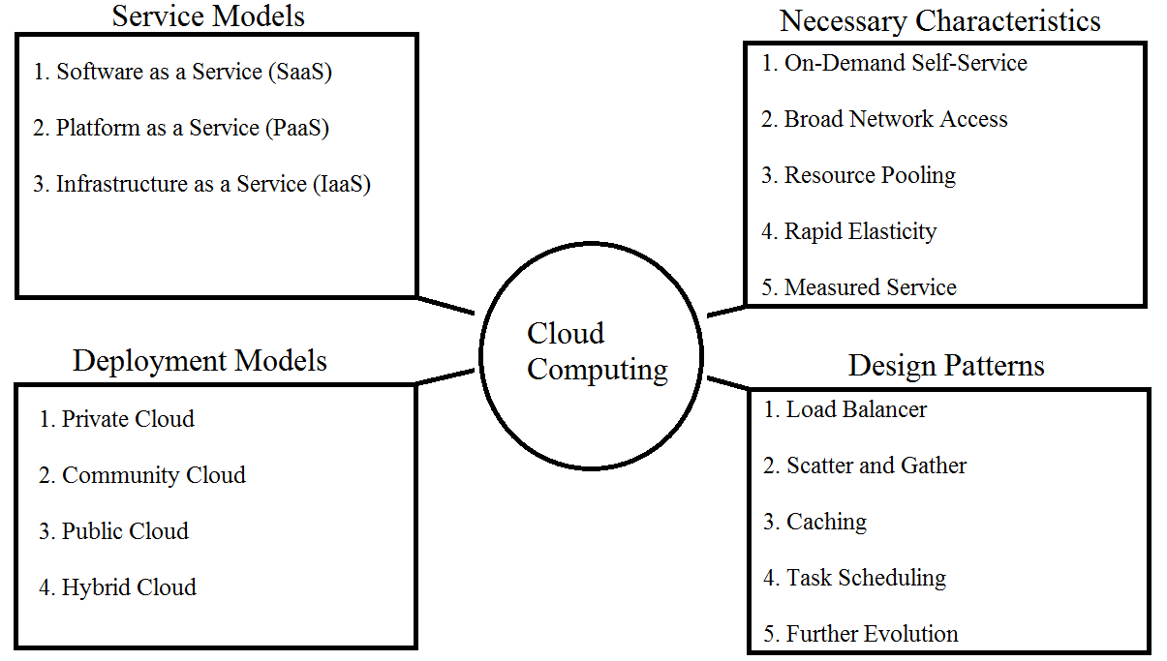

Figure 3 Summary of Cloud Computing: Above indicates all of the primary characteristics that make cloud computing different from normal computing and states the different types of implementation.

1. **Example: Apple**

Apple utilizes cloud computing by sharing their services through iCloud. This allows the consumer to get automatically synchronized contacts, calendars, mail. messages, music, pictures, videos and books through all of their apple products (iPad, iPhone, Mac, Apple TV, iWatch, etc.) [8]. Apple provides services such as iTunes that store information on a remote database and 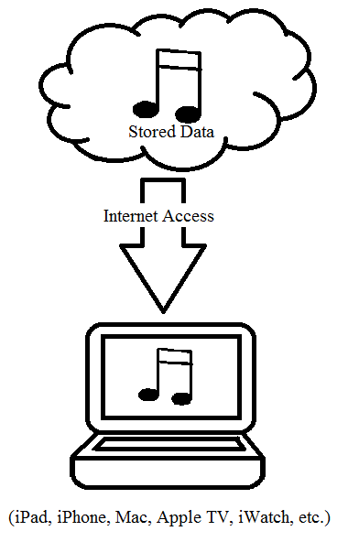allow access to it through the cloud [8]. Whenever an individual is signed into their account on the cloud, they have access to all of their personalized downloads.

Figure Practical Cloud Use: Downloading files (in this case music files) is one of the primary ways to access information on a cloud and utilize it on the consumer’s device.

An example of how design patterns are used in these services is using caching in order to bookmark a page in a book downloaded from Amazon to return to later for reading. This cloud infrastructure has been the defining phenomenon in the world of consumer clouds, and has been expected to make over $6.5 billion by the end of the year [8].

**References**

[1] A. R. Editors and E. D, *Encyclopedia of computer science*, A. Ralston, E. D. Reilly, and D. Hemmendinger, Eds., 4th ed. Chichester, United Kingdom: Wiley, John & Sons, 2000.

[2] B. Benatallah, *Cloud computing: Methodology, systems, and applications*, L. Wang, R. Ranjan, and J. Chen, Eds. Boca Raton, FL: CRC Press, 2011.

[3] D. C. Marinescu, *Cloud computing: Theory and practice*. Boston: Morgan Kaufmann Publishers In, 2013.

[4] E. Brown and G. Swenson, "Final version of NIST cloud computing definition published," NIST, 2016. [Online]. Available: https://www.nist.gov/news-events/news/2011/10/final-version-nist-cloud-computing-definition-published. Accessed: Oct. 27, 2016.

[5] J. Carstensen, B. Golden, and J. Morgenthal, *Cloud computing: Assessing the risks*. London, United Kingdom: It Governance Publishing, 2012.

[6] J. W. Rittinghouse and J. F. Ransome, *Cloud computing: Implementation, management, and security*. Boca Raton, FL: Taylor & Francis, 2009.

[7] V. Josyula, M. Orr, and G. Page, *Cloud computing: Automating the virtualized data center*. Indianapolis, IN: Cisco Press, 2011.

[8] Z. Mahmood, Ed., *Cloud computing: Methods and practical approaches*. London: Springer, 2013.

1. Processor- a machine that manipulates data in a way that is beneficial to the programmer [1].
2. Virtualization- the transition of something actual to something virtual [1]. Includes operating systems, servers, storage devices and network resources [1].
3. Processing- doing a series of operations that change or preserve the information [1].
4. Programming- the process of writing computer programs [1].
5. Cloud Platform- the physical hardware and operating system that provides resources and information that are accessible to clients over the internet [1].
6. Bandwidth- the amount of data that can be transmitted in a certain amount of time [1].
7. Computing Power- a combination of what the processor can compute and the speed of that processor [1].
8. Standard Mechanisms- ways in which all computers can communicate without error [1].
9. Dynamic- capable of action and/or change [1].
10. Infrastructure- the organization of the platform that the system runs on [1].
11. Thin Client- lightweight computer that is purposefully built for remote access to a server [1].
12. Program Interface- a connection with unique routines, protocols and tools [1].
13. Operating Systems- software that does a computer’s basic tasks such as executing applications, scheduling tasks and controlling peripherals [1].
14. Deployed Applications- running new software properly in its environment [1].
15. Standardized and Proprietary- applications that are beneficial to the owner and run on common protocol in order to avoid problems with transferring information between different sets of hardware [1].